**Database for Zen class programme Task**

**Note: the task output has been included in the snap on below question.**

**To create the users collections: To create the codekata collections:**

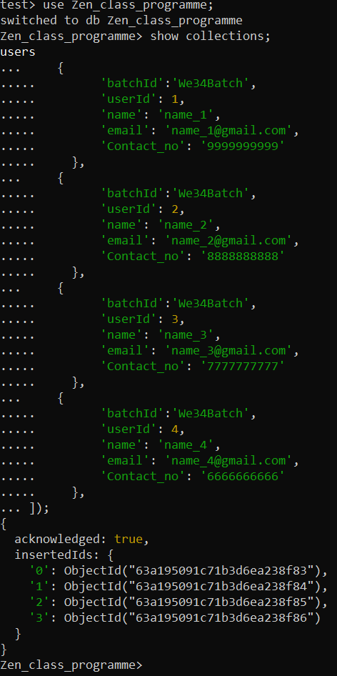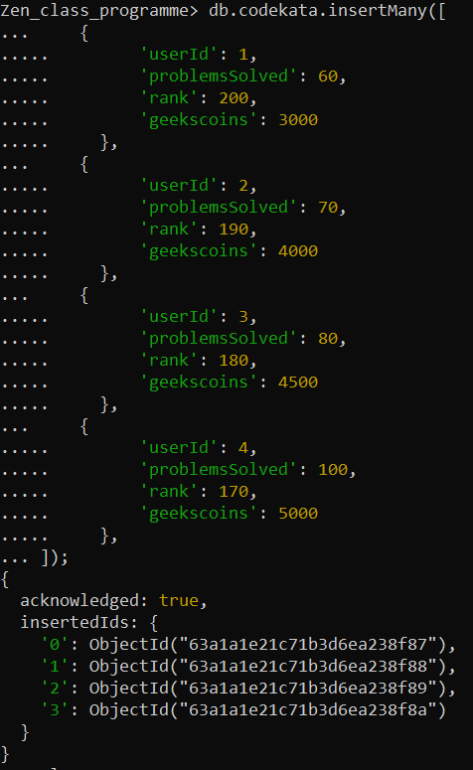

**To create the attendance collections: To create the Topics collections:**

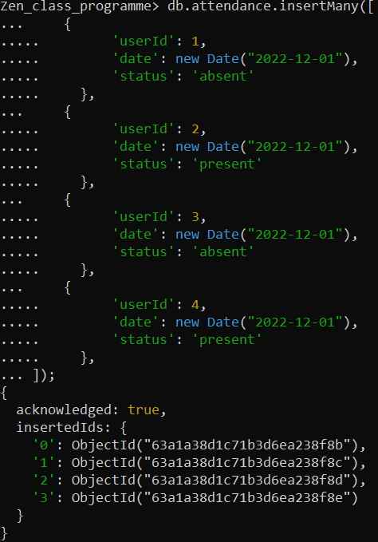 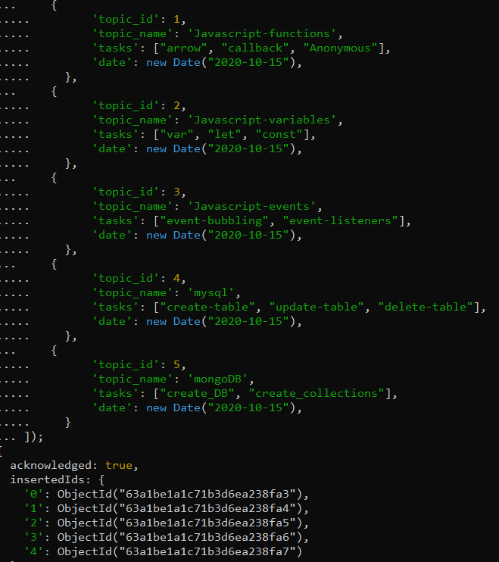

**To create the task collections: To create the company_drives collections:**

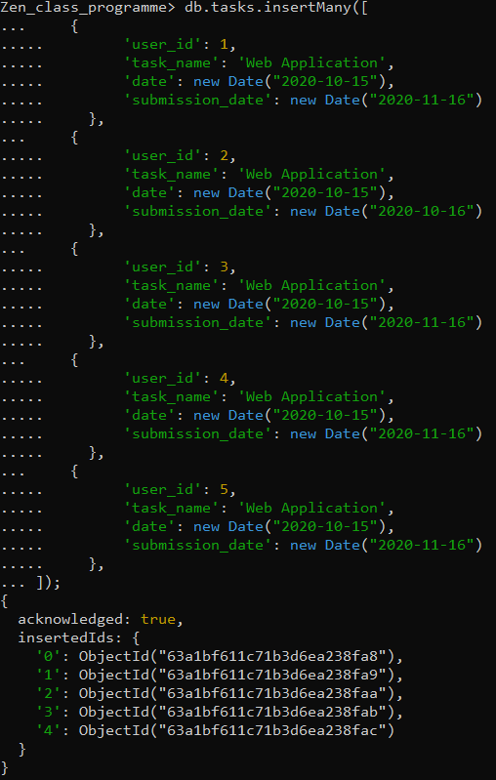 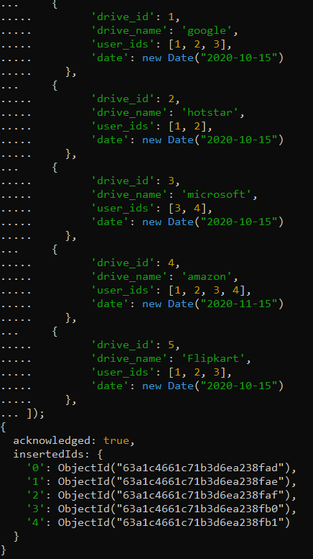

**To create the mentors collections:**

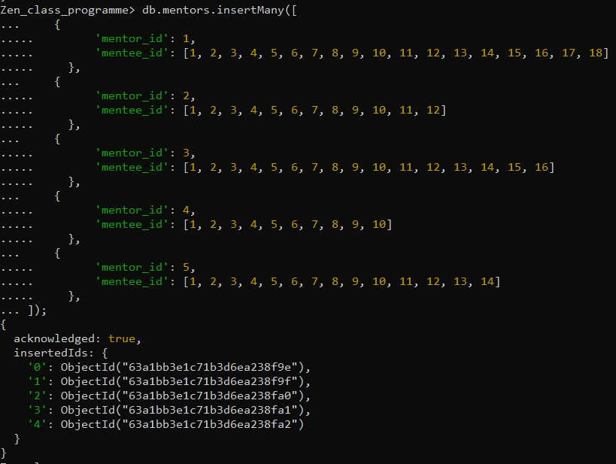

1. Find all the topics and tasks which are thought in the month of October

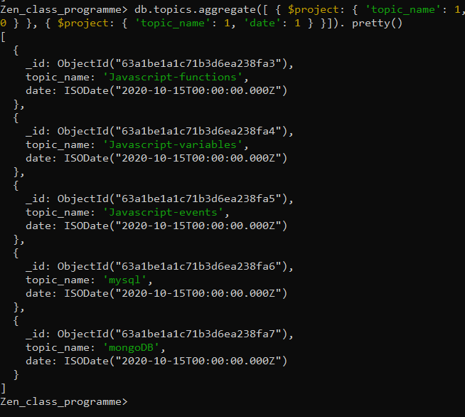 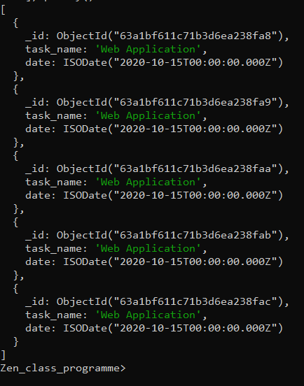

1. Find all the company drives which appeared between 15 oct-2020 and 31-oct-2020

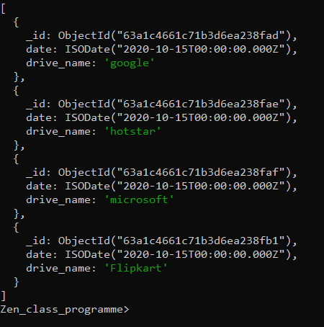

1. Find all the company drives and students who are appeared for the placement.

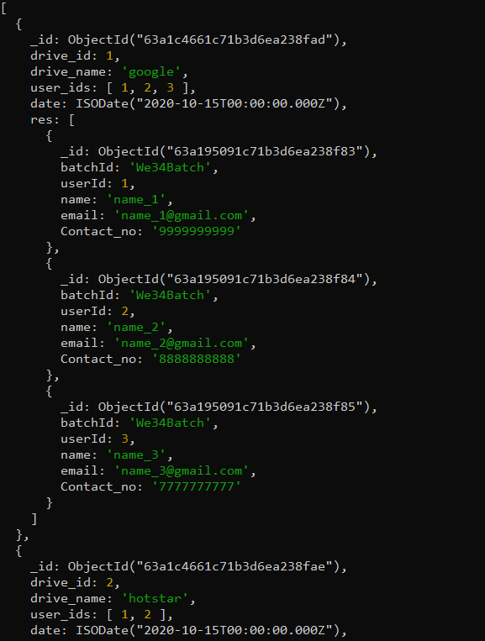

1. Find the number of problems solved by the user in codekata

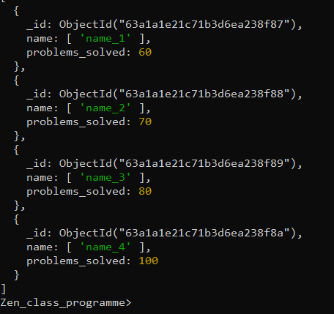

1. Find all the mentors with who has the mentee's count more than 15

